September 14, 2014
Kurt B. Fisher
Solar Charge System Installation

After installing my fifth solar charge system on various trailers, motorhomes, and fifth wheels, I thought that others might benefit from a quick write up on the installation.

First off, let’s talk about price. Most commercial RV sales and repair facilities typically charge around $1500 installed for a basic solar charge system, give or take a few hundred dollars. We’ll learn here how easy it is to install solar on your RV for just over $300.00, including shipping. (Depending on ship to location) My last purchase of the 158 watt kit was $313.00 shipped to Discovery Bay, CA.

Prepare for about 4 man-hours of total installation time, and having a helper when fishing the solar wire down the refrigerator vent is very beneficial. Just take your time and enjoy the process. The end result is much more satisfying this way.

First: The components. I’ve purchased from several vendors online, including direct from China on ebay. My last two systems have been purchased from Miles Heiner of Light Harvest Solar in Portland, and I’ve been more than satisfied with his knowledge, willingness to help, and value. His charge kits can be viewed at: http://www.lightharvestsolar.com/12-volt-battery-kits.html I used his 158 watt kit on two separate fifth wheel trailers, and they’ve been more than adequate for my needs providing a full charge by ~ 9:30 am on two 6 volt golf cart batteries. This after running lights, water pump, etc. the night before.

Measuring for solar wire: Miles’ kits come with 10” of wire if I recall correctly. Most installs require more, and so you can order your exact cut length on his website and send a note with your order specifying that length. Select a location near the refrigerator vent for the solar panel mount on the roof. Then estimate maybe 5’ of length to the vent on the roof from the panel, then about 12’ from the roof top vent down through to the underside of the coach, then the length to the battery compartment where the charge controller will be mounted, then from the controller to the battery terminals. Add these figures for an overall total wire length.

Once you’ve got the components, you’ll want to prepare for the install with a few basic tools including: Wire strippers, electrical tape, Dicor sealant, cordless driver, pilot drills, hex head socket driver, a few wrenches, etc. Nothing out of the ordinary aside from basic tools, with the possible exception of an installers drill bit, or long bit extension for drilling a hole through the floor and up through the refrigerator vent area. (More on this later)

Running the solar charge wire: Much of the following procedure can be done in any sequence you like. I find running the wire to be the most time consuming, so I’ll begin there.

Probably the most difficult aspect of this project is running the wire from the roof top refrigerator vent down and under the coach. My last install just today on my 32E37DS went very smoothly, taking much less time than past installs. You’ll want to begin by drilling a hole in the refrigerator compartment from outside the coach, after removing the refrigerator access door. Locate an open area and drill a hole sufficient for the wire to fit through. Then measure down with a straight edge like a yard stick and drill up into the floor of the coach from underneath, with your best attempt at lining up the holes. This is where your long installer’s drill bit, or an extension comes in handy, as often you will have to drill through two separate layers of wood spaced several inches apart, and possibly some block foam insulation too. Once you’ve done this you should end up with something that looks like this:

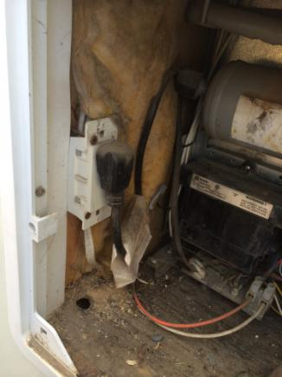

Underside of trailer:
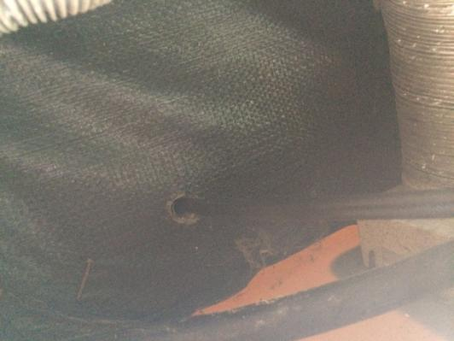

Next you’ll want to go up on the roof and remove the four Phillips head screws that hold the cap on the refrigerator vent. Push down through the sealant on top of the screws, or dig it out to allow access. Remove the cap, make a small hole in the screen, and fish the solar wire bare end down through the vent. (Leaving panel connector end up top) This takes some time and patience, and it goes much better with a helper.

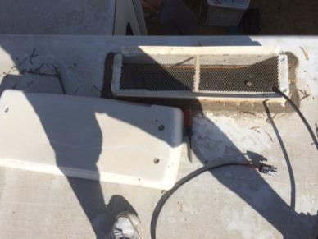
Once you’ve fished the wire down to the refrigerator compartment, tape a stiff fishing wire to the end of the solar wire and fish it down through the floor. It’s usually easier to fish the stiff wire up through the floor and into the refrigerator compartment, then tape the solar wire to it and pull it down through the floor and outside the bottom of the coach.

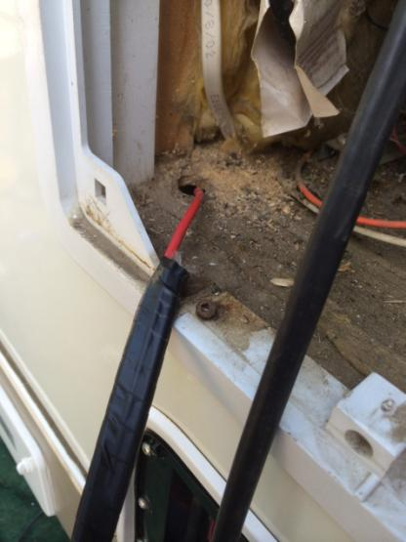

Pull all the wire through to the floor, leaving enough up on the roof to connect to the solar panel after installation. Run the wire underneath the coach and zip tie to any available solid surface:

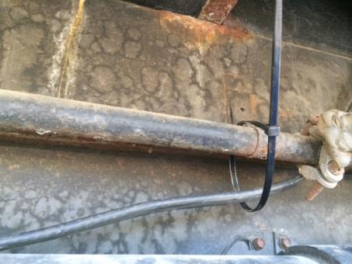

When you reach the battery compartment, drill through the floor if needed, or fish through an existing vent or access hole. Locate a mounting surface for the charge controller in a convenient location, cut the wire to appropriate length, connect to the controller both for the panel input, and battery output, then mount it:
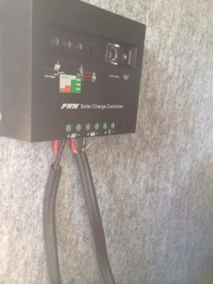
Next install the “Z” mounting brackets on the solar panel. These can be purchased on eBay and online at several sites. I forgot to order these for this install so I bent a couple of building products mounting brackets into shape, cut to size and drilled a few holes. A few examples of online sources include: http://www.ebay.com/itm/like/261313978123?lpid=82 ….or just type in “Solar Z brackets” at Amazon.com

Mounting “Z” brackets is pretty straightforward, but a video is available if any uncertainty: https://www.youtube.com/watch?v=KueFnmlAc7U

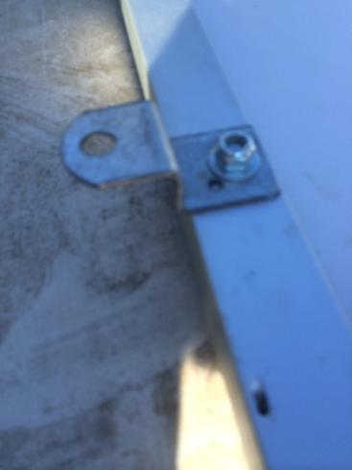

Now it’s time to lift your panel to the roof. A strong helper is a very good thing here. Locate your mounting position, lay the panel in place, drill a small (1/8” or so) pilot drill about 3/8” deep in the center of each Z bracket. Lift the panel slightly and apply a liberal amount of Dicor or similar sealant under the Z bracket. When you set the bracket back in place the sealant should purge from underneath it all around the bracket, providing a good seal. Coat the threads of a short 5/16” galvanized or stainless lag screw (1” or shorter) and screw it in place. (I used a cordless driver with a hex bit for this. Be careful not to over-tighten) Apply sealant over the screw head for complete coverage. Do this for all four mounting brackets:

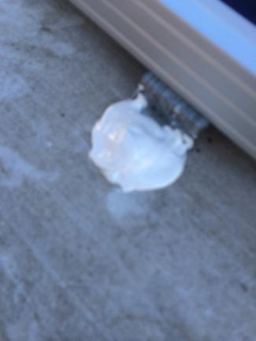

Finally, it’s time to power up your panel! Look for the positive or negative indications on the wire coming from the panel and connect them with correct polarity. The male/female orientation of the connectors should only allow correct connections, with black being negative and red being positive.

To reinstall the refrigerator vent cap I use Eternabond tape to hold the solar wire in position to the roof near the vent. I also install a small piece of screen over the hole made in the vent cap screen:

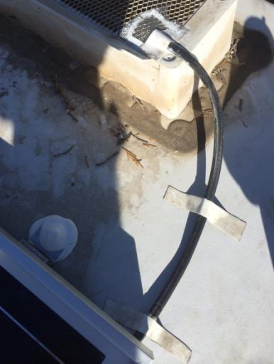

Install the vent cap using the four screws removed, and remember to coat the tops of the screws and fill the holes with sealant. Be sure to go back and fill the holes drilled in the refrigerator compartment and under the coach too:

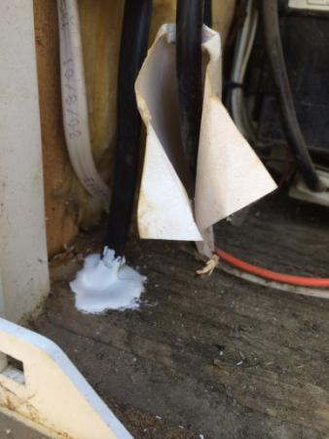

That’s it! You’ve now installed your solar charge system, and saved yourself significant funds in the process!

The really nice thing about the controller sold with this kit is that it has enough capacity (20 amp) should you want to add a second panel. (316 watts) I’ve never found a need for more than one panel as we’re not huge electrical users when dry camping, but a set of Y connectors and another panel easily doubles your charge output if needed.

For added battery life LED replacement light/cards vs the fluorescent or incandescent lights typically installed in most RV’s will provide a significant reduction in electrical power drain on your batteries. (A topic of another future write-up)

Happy camping!

Kurt

